Appsters Industry Page Layout
LOGISTICS
Laid out fold by fold against www.appsters.io/industry
 | DETAIL
Slug | logistics-software-development
Meta Title | Logistics Software Development Company | Appsters
Meta Description | Fleet tracking, route optimization and warehouse apps built for carriers and 3PLs. Cut delays and fuel costs with our logistics app development company. Start your build today.
Layout Source | www.appsters.io/industry
Live Folds | 23
New Blocks Required | 3
FOLD 1: Hero Banner
Hero Banner
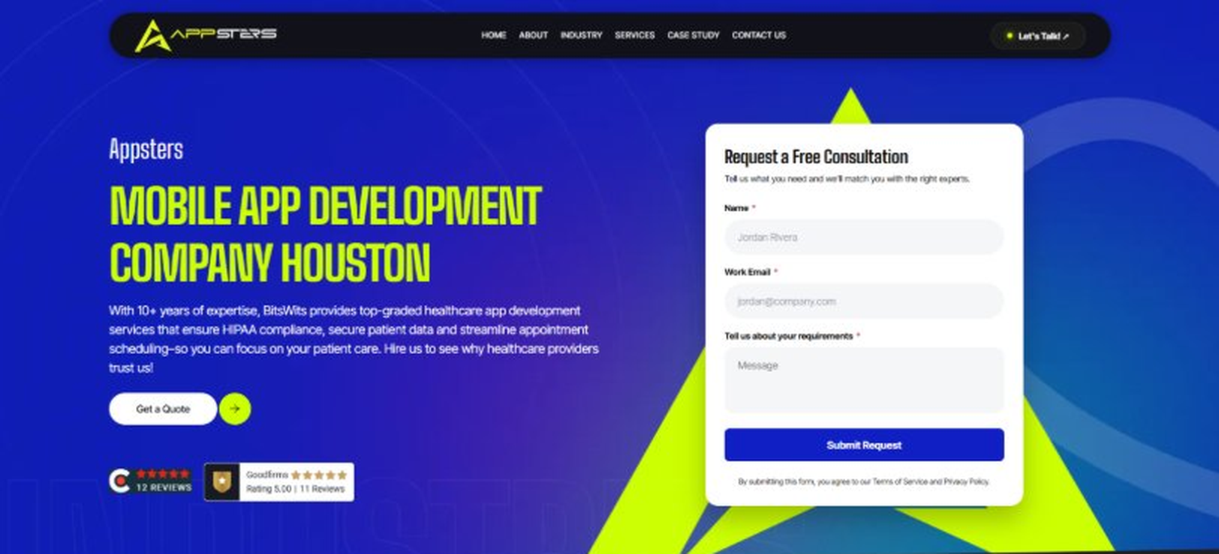
Current live page, www.appsters.io/industry
 | DETAIL
Status | New copy applied
Build Notes | Live block holds H1, sub copy, a Get a Quote button and the Request a Free Consultation form. New copy supplies the H1 and sub copy only.
QA Flag | Live hero copy currently names BitsWits and describes healthcare services. Leftover copy from another build, replace it with the new copy below.
Copy For This Fold
PAGE ELEMENT | COPY (WORD FOR WORD)
H1 (Page Heading) | A Logistics App Development Company Building Platforms That Keep Freight Moving
Body Copy | Delays compound fast, and one missed handoff can throw off an entire supply chain. As a logistics app development company, Appsters builds Logistics apps that keep freight, fleets, and warehouses synced in real time. We build platforms for carriers, 3PLs, and warehouse operators who need visibility they can actually act on, not a dashboard that just looks busy.
FOLD 2: Marquee Strip
Marquee Strip: Turn Your Wildest Ideas Into Powerful Digital Products
Current live page, www.appsters.io/industry
 | DETAIL
Status | No copy change
Build Notes | No new copy in the source document for this fold. Keep the live block exactly as it is.
FOLD 3: Stats Counter
Stats Counter: Work With A Local Mobile App Developer In Houston
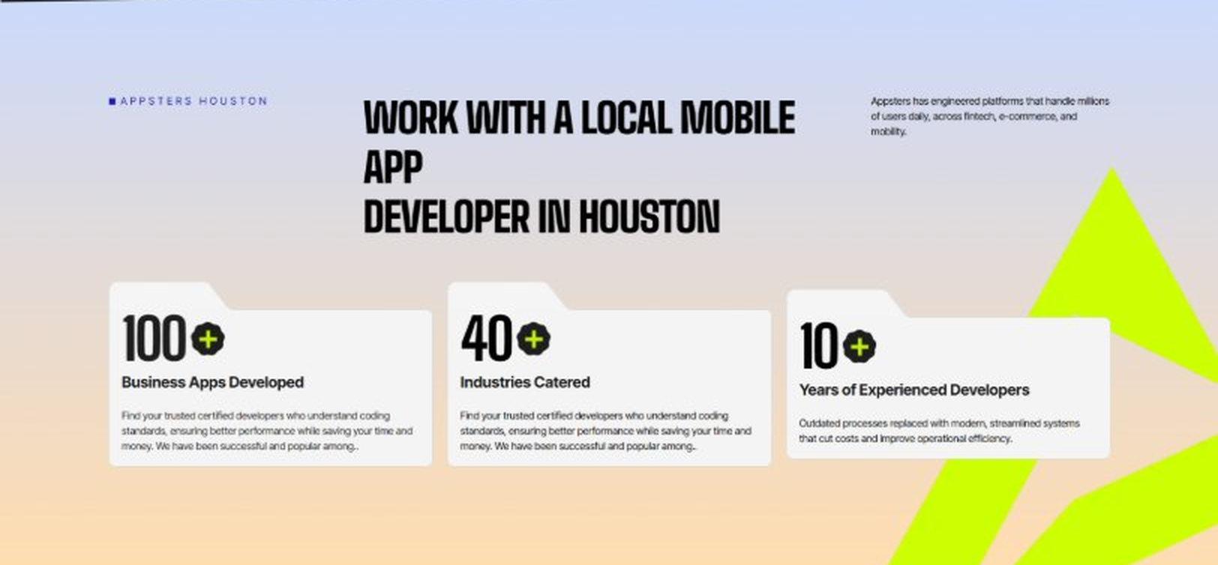
Current live page, www.appsters.io/industry
 | DETAIL
Status | New copy applied
Build Notes | Live block holds 3 counters. New copy holds 6 stats. Either widen the block to 6 or drop two.
Copy For This Fold
PAGE ELEMENT | COPY (WORD FOR WORD)
H2 (Section Heading) | Awarded For Building Logistics Apps That Keep Supply Chains Honest
Body Copy | Our Logistics app development work has earned recognition for route optimization accuracy, uptime, and measurable cost savings for carriers. Appsters has been recognized for delivering platforms that track shipments precisely, flag delays before they cascade, and stay reliable through peak shipping seasons. Every award reflects tested performance, not a sales deck.
Stat 1 Number | 40+
Stat 1 Label | Industries Served
Stat 1 Copy | Our experience spans social platforms, marketplaces, fintech, healthcare, and more, with solutions adapted to each sector's demands for security, AI, compliance, and user adoption.
Stat 2 Number | 3000+
Stat 2 Label | Apps and Solutions Delivered
Stat 2 Copy | Thousands of projects executed with an emphasis on speed, AI adoption, stability, and clear ROI across both startup and enterprise environments.
Stat 3 Number | 60+
Stat 3 Label | AI Models Deployed
Stat 3 Copy | Every model is designed for high accuracy, reliable outputs, and performance at scale for mission-critical workflows and more.
Stat 4 Number | 50,000+
Stat 4 Label | Legacy Processes Modernized
Stat 4 Copy | Outdated processes replaced with modern, streamlined systems that cut costs and improve operational efficiency.
Stat 5 Number | 250+
Stat 5 Label | Engineers and Designers
Stat 5 Copy | A global team skilled in native mobile app development, AI-driven ecosystems, cross-platform builds, and enterprise architecture.
Stat 6 Number | 95%
Stat 6 Label | Client Retention
Stat 6 Copy | Long-term partnerships built on trust, consistent delivery, and continuous optimization of live applications.
FOLD 4: Marquee Strip
Marquee Strip: Mobile App Development Services
Current live page, www.appsters.io/industry
 | DETAIL
Status | No copy change
Build Notes | No new copy in the source document for this fold. Keep the live block exactly as it is.
FOLD 5: Services Grid
Services Grid: Our Comprehensive Mobile App Development Services In Houston
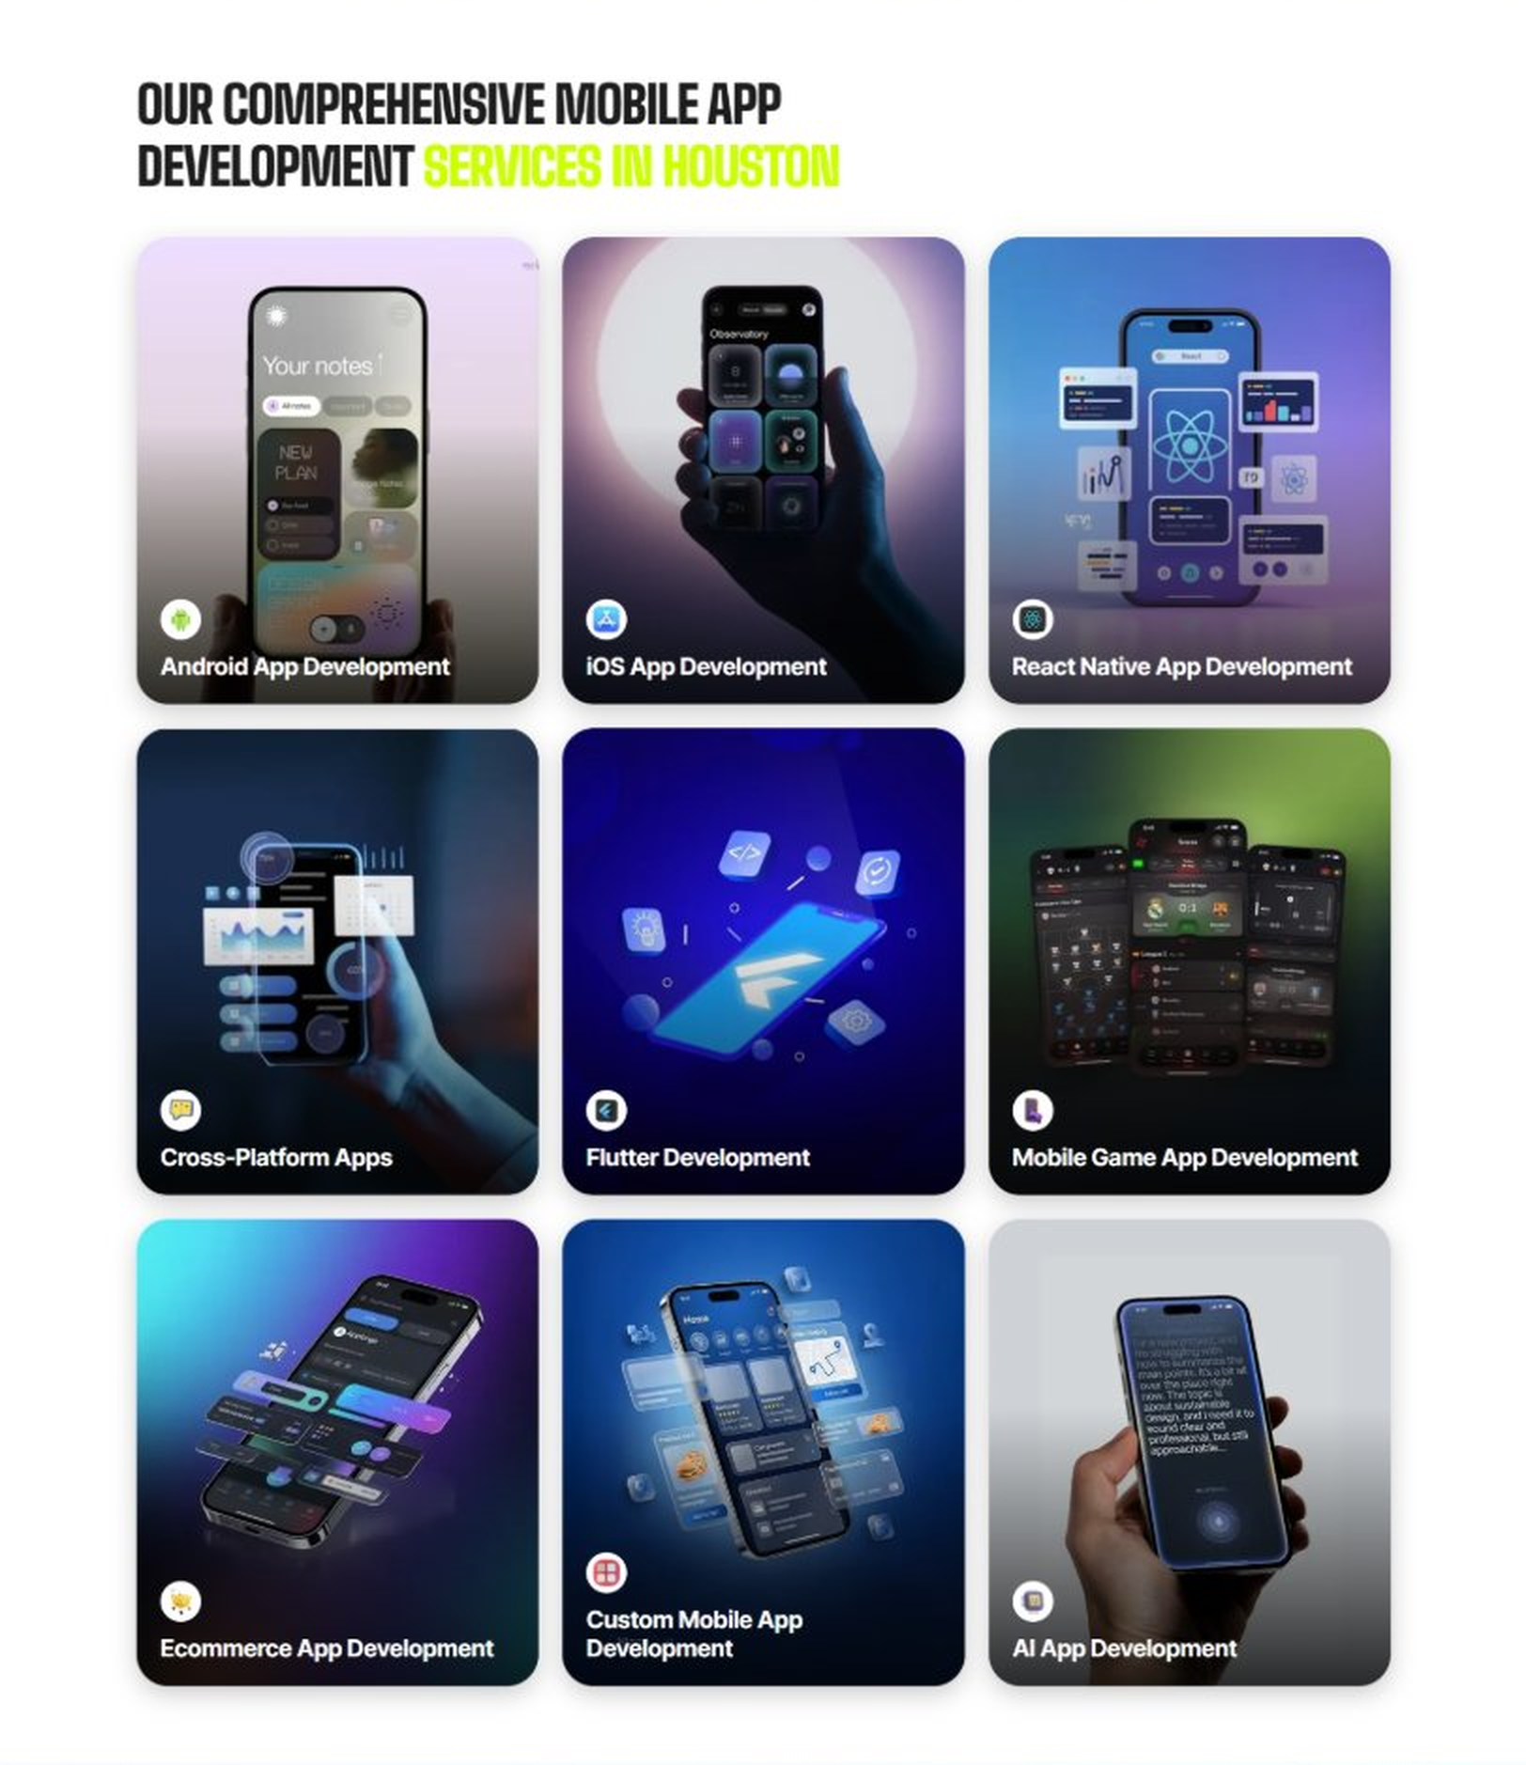
Current live page, www.appsters.io/industry
 | DETAIL
Status | New copy applied
Build Notes | Live grid holds 9 cards. New copy holds 5 services. Either trim the grid to 5 or brief four more services.
Copy For This Fold
PAGE ELEMENT | COPY (WORD FOR WORD)
H2 (Section Heading) | Logistics Application Development Services Built For Supply Chains That Can't Afford Downtime
Body Copy | Strong logistics platforms sit at the crossroads of routing, tracking, and warehouse coordination. As a logistics app development company, we connect operational thinking with technical precision. Appsters' senior developers build platforms that support live GPS tracking, automated dispatch, and inventory sync for carriers, warehouses, and last-mile delivery teams.
Service 1 Heading | Logistics Finder App Development
Service 1 Copy | As Logistics app developers, we build discovery tools that match shippers with available carriers and capacity in real time. Smart matching logic, rate comparison, and load-board-style search replace slow manual booking with something dispatchers actually rely on.
Service 2 Heading | Food Ordering App Development
Service 2 Copy | Cold-chain and last-mile delivery increasingly overlap with food logistics, and our food ordering app developers know how to build ordering flows that plug straight into a broader fleet management system. One dispatch engine handles groceries, meal kits, and freight without needing separate platforms.
Service 3 Heading | Food Delivery App Development
Service 3 Copy | As a food delivery app development company, we build routing and fulfillment layers that work whether the cargo is a pallet or a grocery order, with live tracking that keeps both dispatchers and end customers informed.
Service 4 Heading | Discounts App Development
Service 4 Copy | Our Logistics discounts app development work helps carriers and 3PLs reward repeat shippers with volume-based pricing, loyalty tiers, and referral incentives built directly into the booking flow.
Service 5 Heading | Logistics Review & POS Software Development
Service 5 Copy | For warehouse and depot operations, our POS software development company expertise connects billing, driver reviews, and load history into one system, so operations managers see accurate numbers without chasing spreadsheets.
FOLD 6: Case Study CTA
Case Study CTA: HELPP
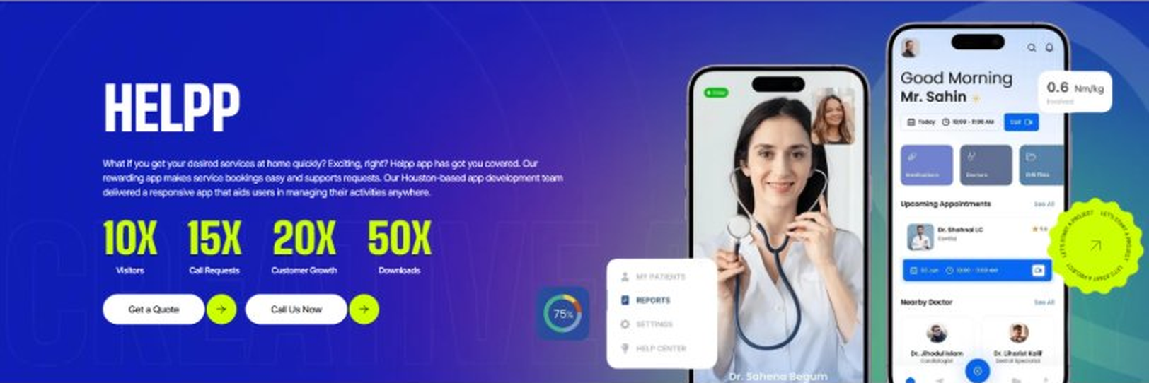
Current live page, www.appsters.io/industry
 | DETAIL
Status | New copy applied
Build Notes | Live block holds a product name, a paragraph, four metric counters and two CTA buttons. New copy supplies the heading and paragraph. Metrics still need to be supplied.
Copy For This Fold
PAGE ELEMENT | COPY (WORD FOR WORD)
H2 (Section Heading) | Logistics App Developers Who Build For Uptime, Not Just Features
Body Copy | Launching a tracking app is easy. Keeping it accurate under real freight volume is the hard part. If you're ready to build Logistics apps that dispatchers actually trust, Appsters is the partner that gets you there. Let's talk about your fleet, your routes, and what a platform built to scale actually requires.
FOLD 7: Testimonials
Testimonials: Real Stories From People Who Wanted What’s Next

Current live page, www.appsters.io/industry
 | DETAIL
Status | New copy applied
Build Notes | Live block runs video testimonials. New copy is written quotes with attributions. Source document marks this fold design TBD.
Copy For This Fold
PAGE ELEMENT | COPY (WORD FOR WORD)
H2 (Section Heading) | What Our Clients Say
Testimonial 1 Quote | "We were running three different systems before Appsters consolidated everything into one dispatch platform. Our dispatchers stopped hating Mondays. That alone made the investment worth it."
Testimonial 1 Attribution | Frank Delgado, Operations Director
Testimonial 2 Quote | "I was skeptical route optimization software could actually beat what our senior dispatcher did by feel after twenty years. It did, within the first month, and he's the first to admit it now."
Testimonial 2 Attribution | Nadia Okafor, VP of Fleet Operations
Testimonial 3 Quote | "Peak season used to mean overtime, missed windows, and angry customers. This past holiday season was the calmest one we've had since I started here eight years ago."
Testimonial 3 Attribution | Terrence Boyle, Warehouse Manager
Testimonial 4 Quote | "We needed compliance logic built in from day one given how many states we operate across. Appsters got that right without us having to explain it twice."
Testimonial 4 Attribution | Alina Petrov, Chief Compliance Officer
Testimonial 5 Quote | "What impressed me most was how the app held up during a massive volume spike we didn't even warn them about. It just worked, which is honestly rare in this industry."
Testimonial 5 Attribution | Marcus Webb, Chief Operating Officer
Source document note: Testimonial fold, design TBD after content
FOLD 8: Technology Logo Strip
Technology Logo Strip

Current live page, www.appsters.io/industry
 | DETAIL
Status | No copy change
Build Notes | No new copy in the source document for this fold. Keep the live block exactly as it is.
FOLD 9: Why Choose Us
Why Choose Us: Compelling Reasons To Choose Us As A Trustable App Development Company In Houston
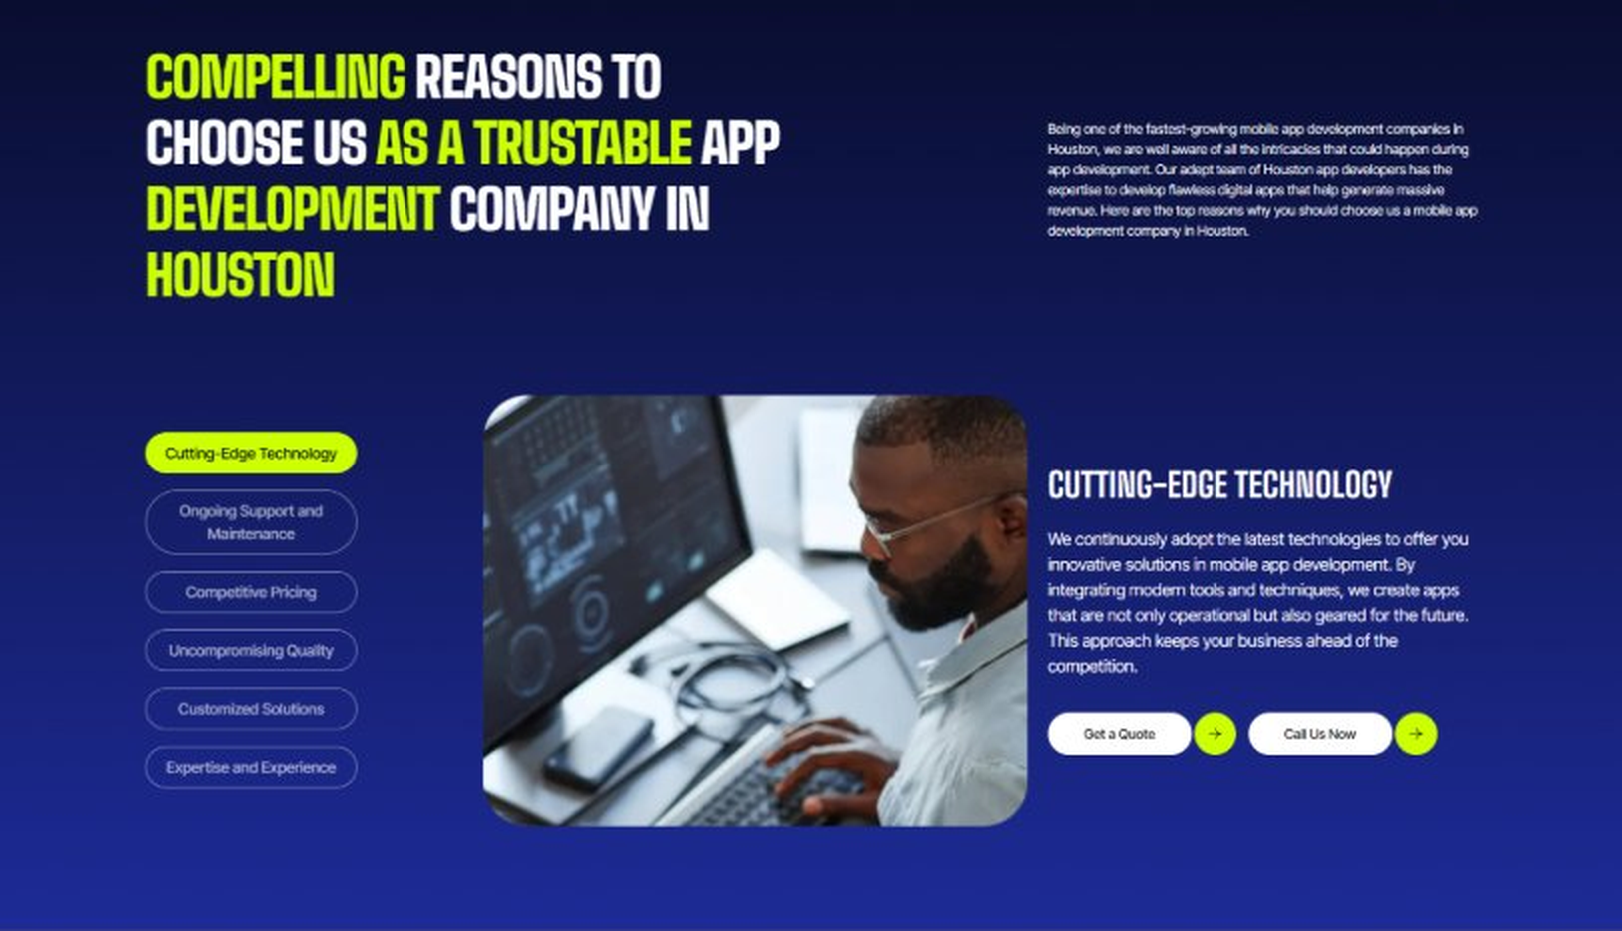
Current live page, www.appsters.io/industry
 | DETAIL
Status | New copy applied
Build Notes | Live block holds 6 tabs. New copy holds 6 reasons. Clean one to one fit, no design change needed.
Copy For This Fold
PAGE ELEMENT | COPY (WORD FOR WORD)
H2 (Section Heading) | Why Carriers And 3PLs Choose Appsters As Their Trusted Logistics App Partner
Body Copy | Choosing a logistics app development partner shapes whether your operations run smoothly or stay stuck fighting fires. Our team blends operational thinking, engineering discipline, and routing expertise to build apps that actually reduce cost, not just add another dashboard.
Reason 1 Heading | Accuracy-First Architecture
Reason 1 Copy | We design every feature around real-time accuracy, backed by live GPS and sensor data rather than estimates.
Reason 2 Heading | Built-In Compliance Logic
Reason 2 Copy | Hours of service, weight limits, and regional regulations aren't bolted on later. Our systems check compliance automatically as routes get built.
Reason 3 Heading | Peak-Season Engineering
Reason 3 Copy | Our architecture is stress-tested for holiday shipping surges, so a volume spike becomes a good problem, not an outage.
Reason 4 Heading | Driver-First Usability
Reason 4 Copy | From routing to check-ins, we design driver-facing tools simple enough to use one-handed at a loading dock.
Reason 5 Heading | Transparent Development Cycles
Reason 5 Copy | We follow sprint cadences with review checkpoints and shared roadmaps, so clients always know what's shipping and what's improving.
Reason 6 Heading | Long-Term Platform Thinking
Reason 6 Copy | We structure apps as ecosystems that evolve with fleet growth and shifting delivery demand, built for longevity rather than a single launch cycle.
FOLD 10: Sector Tabs
Sector Tabs: Serving 40+ Sectors With Mobile App Development In Houston
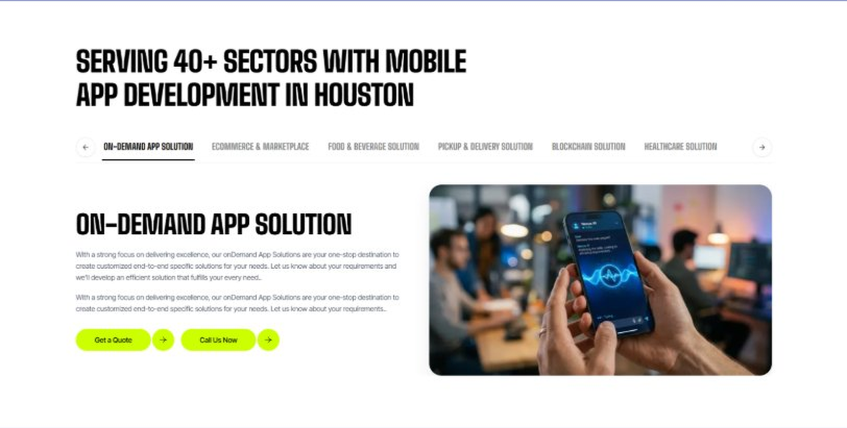
Current live page, www.appsters.io/industry
 | DETAIL
Status | New copy applied
Build Notes | Live block holds 6 sector tabs. New copy holds 5 solutions. Drop one tab or brief a sixth solution.
Copy For This Fold
PAGE ELEMENT | COPY (WORD FOR WORD)
H2 (Section Heading) | Logistics App Solutions Built For Every Link In The Supply Chain
Body Copy | Appsters delivers Logistics app solutions that cover everything from warehouse coordination to last-mile delivery tools. Our systems are architected by senior Logistics app developers who focus on routing accuracy, uptime, and stable performance. Through our Logistics app development services, we help organizations build platforms that feel dependable, fast, and built to handle real freight volume.
Solution 1 Heading | Event Management Apps
Solution 1 Copy | Our event logistics tools help coordinate large-scale deliveries and setups for trade shows and conferences, managing vendor arrival windows so nothing gets stuck at a loading dock during setup.
Solution 2 Heading | Corporate Events Apps
Solution 2 Copy | We build internal logistics apps for companies coordinating multi-site equipment moves and supply distribution, replacing spreadsheets with a system that actually tracks where everything is.
Solution 3 Heading | Subscription-Based Meal Apps
Solution 3 Copy | We build subscription-based delivery logistics for meal kit and grocery subscription companies, routing recurring orders efficiently so delivery windows stay predictable week after week.
Solution 4 Heading | Cloud Kitchen Apps
Solution 4 Copy | We connect cloud kitchen operations to delivery fleet management, giving multi-location food brands one dispatch system instead of juggling separate delivery apps per kitchen.
Solution 5 Heading | Inventory Management Apps
Solution 5 Copy | Real-time inventory management sits at the center of everything we build for warehouses and 3PLs, keeping stock counts accurate across multiple facilities without manual reconciliation.
FOLD 11: Engagement Models Table
Engagement Models Table: Flexible Engagement Models For Any App Development Need
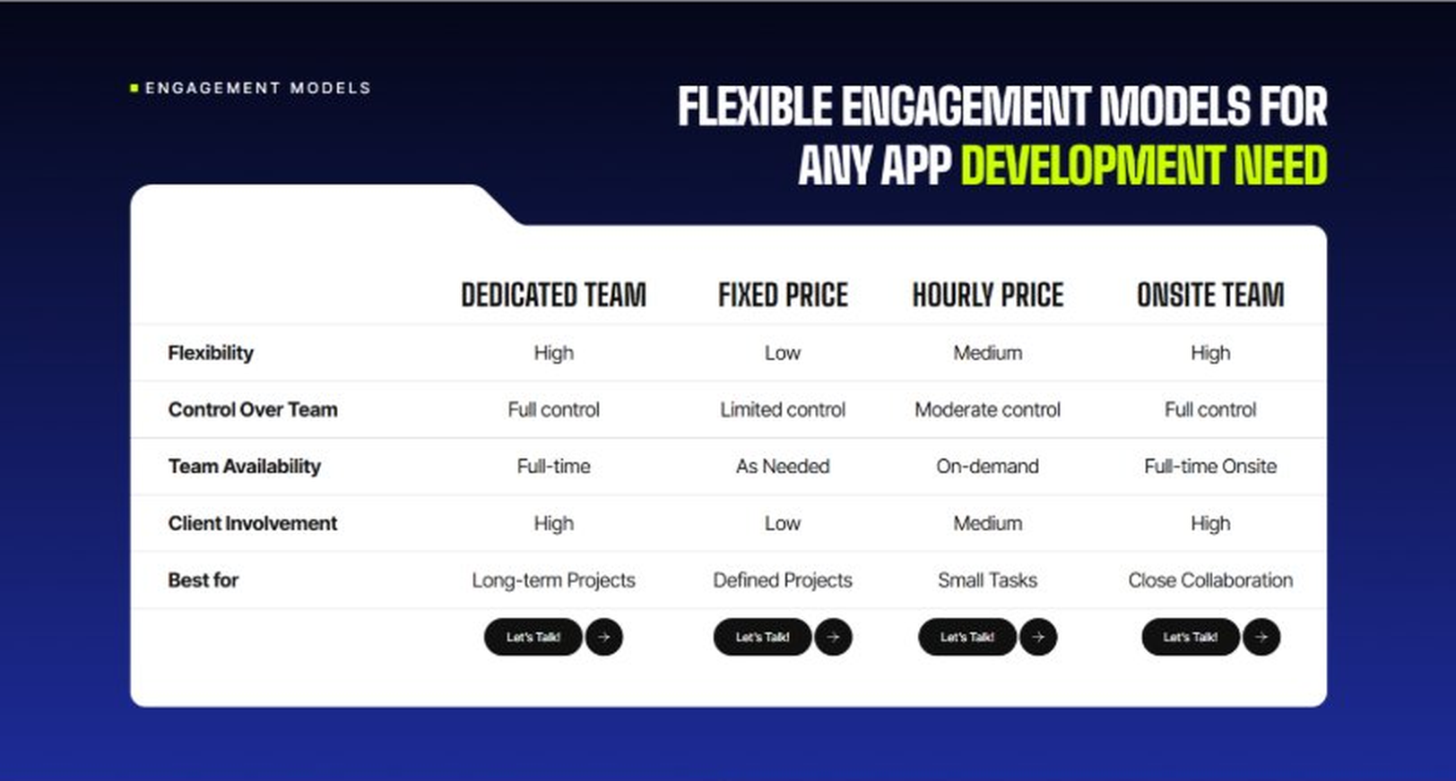
Current live page, www.appsters.io/industry
 | DETAIL
Status | No copy change
Build Notes | No new copy in the source document for this fold. Keep the live block exactly as it is.
FOLD 12: Game App CTA
Game App CTA: Into Engaging Mobile Games
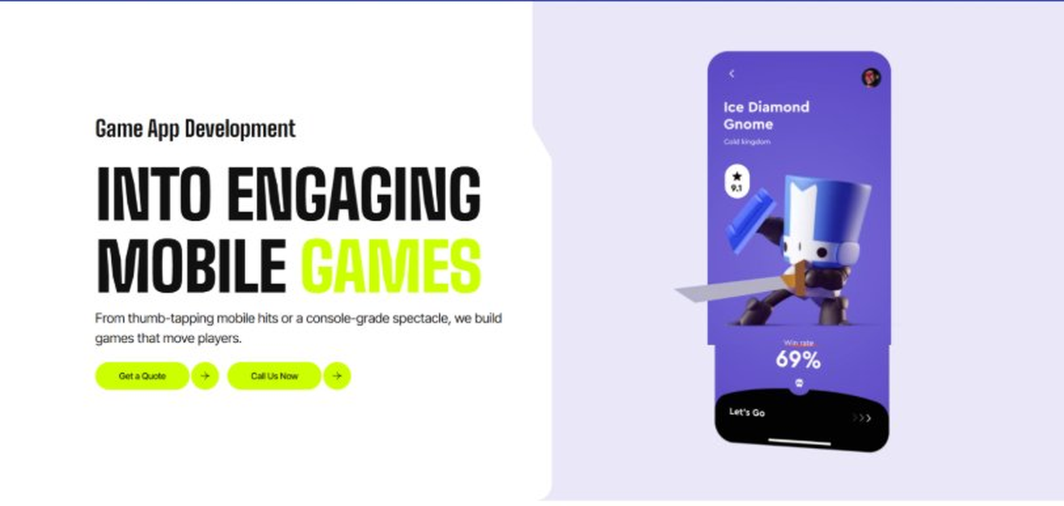
Current live page, www.appsters.io/industry
 | DETAIL
Status | No copy change
Build Notes | No new copy in the source document for this fold. Keep the live block exactly as it is.
FOLD 13: Collaboration And Client Logos
Collaboration And Client Logos
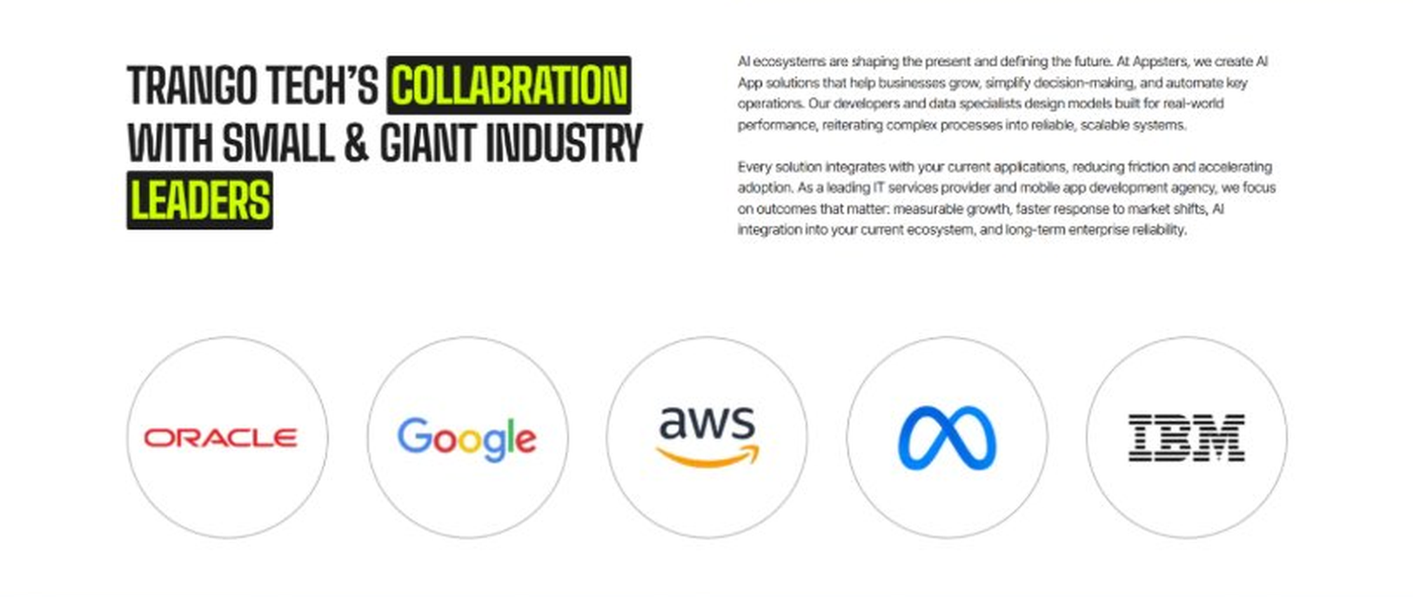
Current live page, www.appsters.io/industry
 | DETAIL
Status | No copy change
Build Notes | No new copy in the source document for this fold. Keep the live block exactly as it is.
QA Flag | Live heading reads "Trango Tech’s Collabration with Small & Giant Industry Leaders". That is a competitor name plus a spelling error sitting live on the page. Fix regardless of this content drop.
FOLD 14: Recognition CTA Banner
Recognition CTA Banner
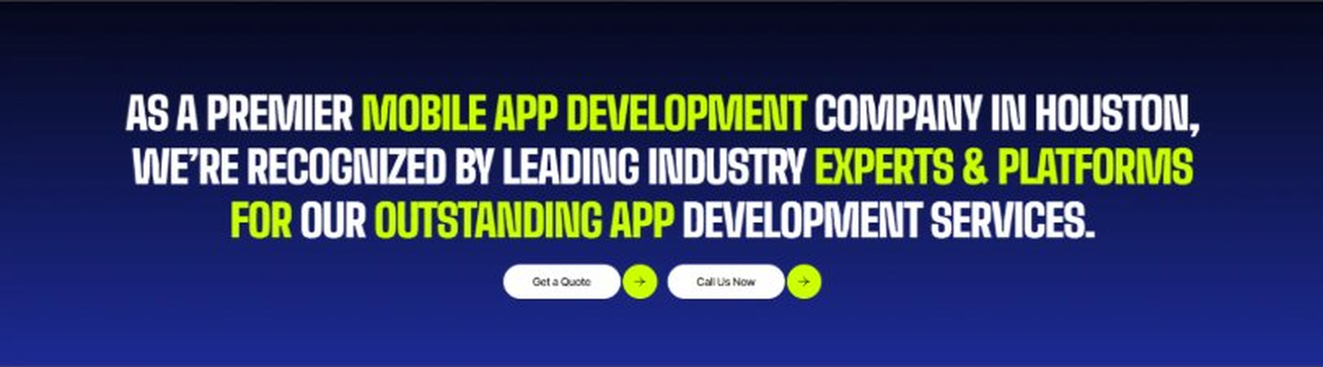
Current live page, www.appsters.io/industry
 | DETAIL
Status | New copy applied
Build Notes | Live block holds a headline and two CTA buttons. New copy supplies the heading and paragraph.
Copy For This Fold
PAGE ELEMENT | COPY (WORD FOR WORD)
H2 (Section Heading) | The Next Shipment Is Already Late Somewhere. Is Your Platform Ready To Launch?
Body Copy | Every day you wait is a day another carrier gets ahead on visibility and efficiency. Let's build a Logistics app that keeps your fleet accountable and your customers informed. Talk to Appsters today, and let's figure out what your first release actually needs to look like.
FOLD 15: Market Presence And Office Map
Market Presence And Office Map: Expand Your Market Presence
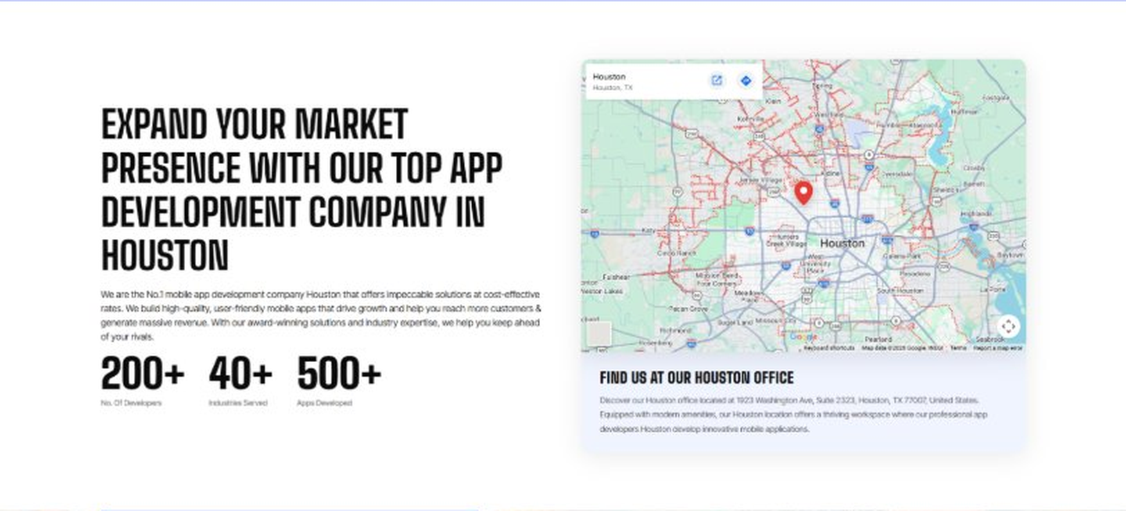
Current live page, www.appsters.io/industry
 | DETAIL
Status | New copy applied
Build Notes | Live block holds a heading, a paragraph, three counters and the office map. New copy supplies the heading and paragraph.
Copy For This Fold
PAGE ELEMENT | COPY (WORD FOR WORD)
H2 (Section Heading) | Food Ordering App Development Company Expertise Behind Every Logistics Platform We Build
Body Copy | As a team that knows how to develop mobile Logistics apps at scale, we bring the same rigor to embedded ordering and delivery features. Our engineers have shipped AI-based food delivery apps, route optimization engines, and warehouse systems, giving us a deeper bench than studios that only build tracking dashboards. React Native, Swift, Kotlin, Node.js, and real-time GPS APIs form our core stack, paired with AI models tuned for route prediction, demand forecasting, and fraud detection. Where most competitors bolt commerce onto a tracking app, we design the two to work as one system.
FOLD 16: Portfolio
Portfolio: Quick Glimpse On Our Portfolio

Current live page, www.appsters.io/industry
 | DETAIL
Status | New copy applied
Build Notes | Live block holds a heading, a paragraph and one CTA. New copy holds an intro plus 4 named product cards. Source document marks this fold design TBD.
Copy For This Fold
PAGE ELEMENT | COPY (WORD FOR WORD)
H2 (Section Heading) | Logistics Products Engineered For Supply Chains That Don't Break
Body Copy | Appsters builds logistics platforms that behave like long-term infrastructure, not a one-off tracking tool. Our solutions stand out because they blend routing algorithms, warehouse logic, and driver behavior analytics in one stable system. Every product is architected for accuracy, uptime, and measurable cost reduction.
Product 1 Heading | FleetPulse
Product 1 Copy | FleetPulse is a fleet management app built for mid-size carriers who outgrew spreadsheets but weren't ready for enterprise software costs. Live GPS tracking, automated maintenance alerts, and driver scorecards keep operations tight. Dispatchers get a single view of every truck on the road without switching between five tools.
Product 2 Heading | DockLine
Product 2 Copy | DockLine is a warehouse coordination app that manages dock scheduling, inventory sync, and loading crew assignments in real time. Drivers get exact arrival windows, warehouse staff avoid bottlenecks, and nobody sits waiting in a yard for an hour.
Product 3 Heading | RouteForge
Product 3 Copy | RouteForge is an AI-driven route optimization app that recalculates delivery routes on the fly based on traffic, weather, and driver hours of service. Fuel costs drop and on-time rates climb without dispatchers manually replanning every route by hand.
Product 4 Heading | CargoTrack
Product 4 Copy | CargoTrack is a shipment visibility app that gives shippers real-time status on freight from pickup to delivery, with automated alerts the moment a shipment deviates from its expected timeline.
Source document note: Portfolio fold, design TBD after content
FOLD 17: Tech Stack Tabs
Tech Stack Tabs: Mobile App Development, A Tech Stack For The Bold
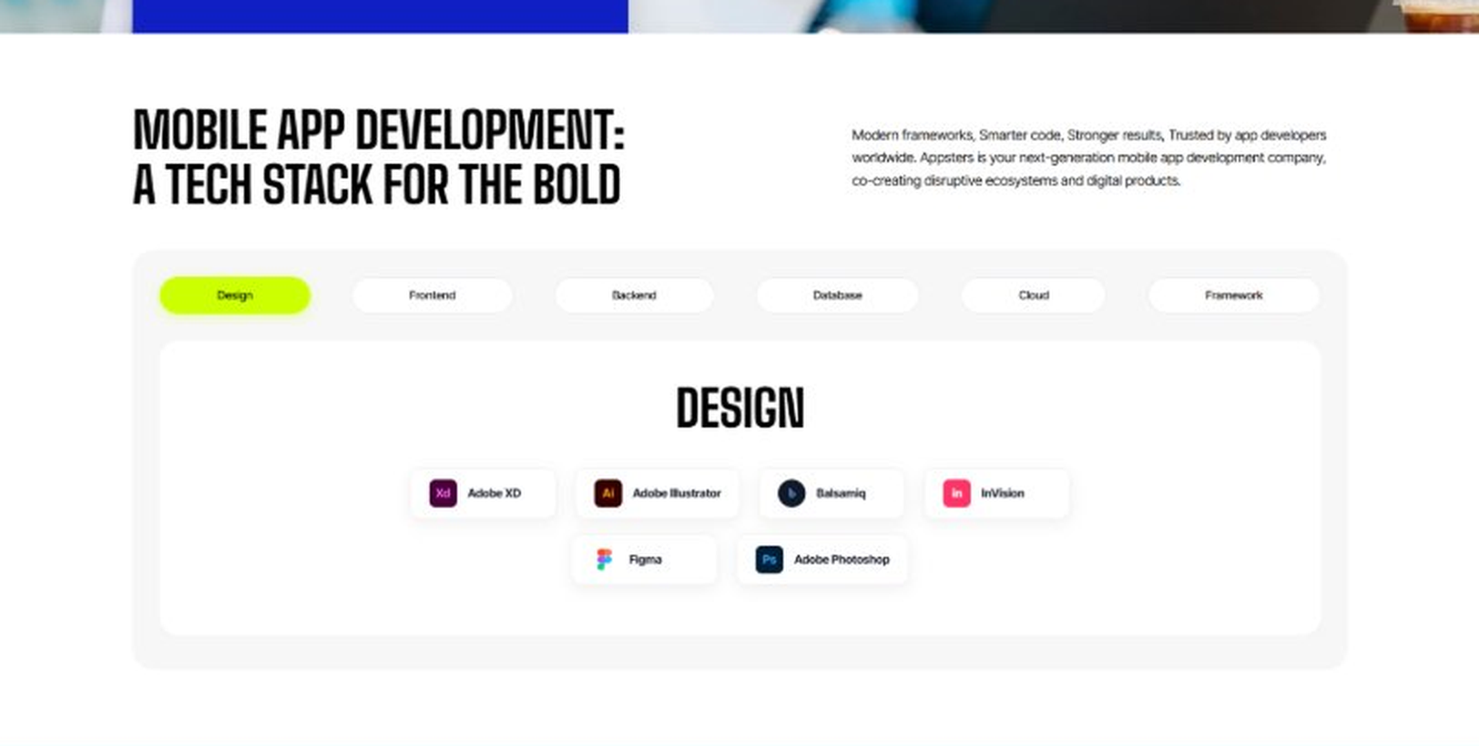
Current live page, www.appsters.io/industry
 | DETAIL
Status | New copy applied
Build Notes | Live block holds 6 category tabs with tool logos. New copy supplies the heading and paragraph, the tab contents stay as they are.
Copy For This Fold
PAGE ELEMENT | COPY (WORD FOR WORD)
H2 (Section Heading) | Technology Stack That Powers High-Performance Logistics Applications
Body Copy | Our engineering foundation supports live GPS tracking, heavy data traffic, and platform-wide scalability. Through our Logistics application development services, we use Swift, Kotlin, Flutter, React Native, Node.js, real-time geolocation APIs, and secure cloud infrastructure alongside AI-driven routing engines. Every stack decision reinforces speed, accuracy, and long-term flexibility so your platform can grow without a rebuild, whether that growth means ten more trucks or ten more warehouses.
FOLD 18: Process
Process: App Development Process
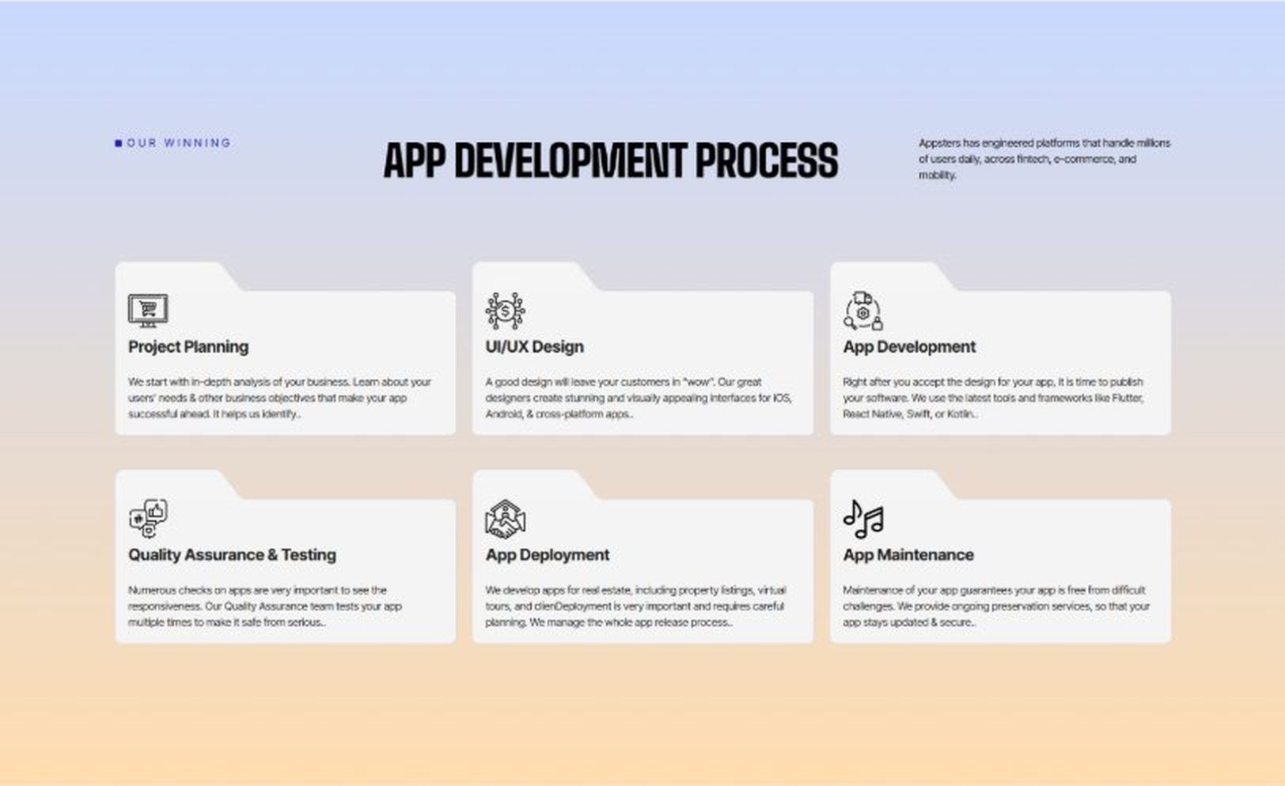
Current live page, www.appsters.io/industry
 | DETAIL
Status | New copy applied
Build Notes | Live block holds 6 step cards. New copy holds 8 steps. Either widen the block to 8 or merge two steps.
Copy For This Fold
PAGE ELEMENT | COPY (WORD FOR WORD)
H2 (Section Heading) | Logistics App Development Process Built For Platforms That Hold Up Under Load
Body Copy | A logistics platform needs more than a map view. It needs structure, clarity, and a process engineered for accuracy, scale, and reliability from day one. Our Logistics app development process aligns operational goals with technical roadmaps so every phase moves with intention.
Step 1 Heading | App Idea & Research
Step 1 Copy | Every project begins with structured discovery, where our teams map fleet operations, warehouse workflows, and delivery patterns. We benchmark performance against existing platforms and define what will actually cut costs and delay for your operation. By the time research closes, the product's purpose, risks, and growth path are already clear.
Step 2 Heading | Strategic Planning & Consultation
Step 2 Copy | Here we translate research into a measurable plan. Our strategists define the technical architecture, routing logic, integration needs, and delivery milestones needed to build your AI Logistics mobile app the right way, from the first sprint.
Step 3 Heading | Wireframing & Prototyping
Step 3 Copy | We turn ideas into tangible user journeys. Wireframes capture dispatcher workflows, driver app screens, and warehouse interfaces in a visual structure stakeholders can react to before a single line of code gets written.
Step 4 Heading | App Development
Step 4 Copy | This is where engineering takes over. Our developers implement routing algorithms, tracking systems, dispatch tools, and inventory sync with the same discipline a food app development company applies to order accuracy and uptime. Development stays sprint-driven and transparent throughout.
Step 5 Heading | Expert QA & Testing
Step 5 Copy | Quality assurance covers far more than bug hunting. We validate GPS accuracy, routing logic under real traffic conditions, cross-device behavior, and data sync reliability. Only stable, predictable behavior earns approval to move forward.
Step 6 Heading | App Launch
Step 6 Copy | Launch is a coordinated rollout, not a leap of faith. We manage store compliance, driver onboarding flow, and final performance checks so your platform enters operation ready to hold real freight volume.
Step 7 Heading | Deployment
Step 7 Copy | Our deployment pipelines are built for consistency and safety. We configure cloud infrastructure, optimize for real-time GPS data at scale, and calibrate autoscaling so your app performs the same for 100 vehicles as it does for 10,000.
Step 8 Heading | Maintenance & Support
Step 8 Copy | Post-launch, we keep monitoring routing accuracy, refining dispatch logic, patching vulnerabilities, and responding to new compliance or app store requirements, so your fleet operations keep improving long after day one.
Source document note: Process fold, design TBD after content
FOLD 19: Blog Posts
Blog Posts: Our Related Blog Posts
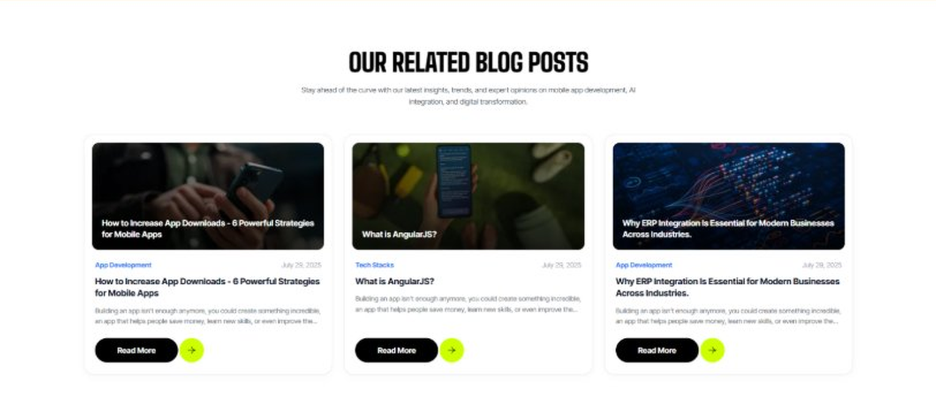
Current live page, www.appsters.io/industry
 | DETAIL
Status | No copy change
Build Notes | No new copy in the source document for this fold. Keep the live block exactly as it is.
FOLD 20: FAQs
FAQs: Your Questions, Our Clarity
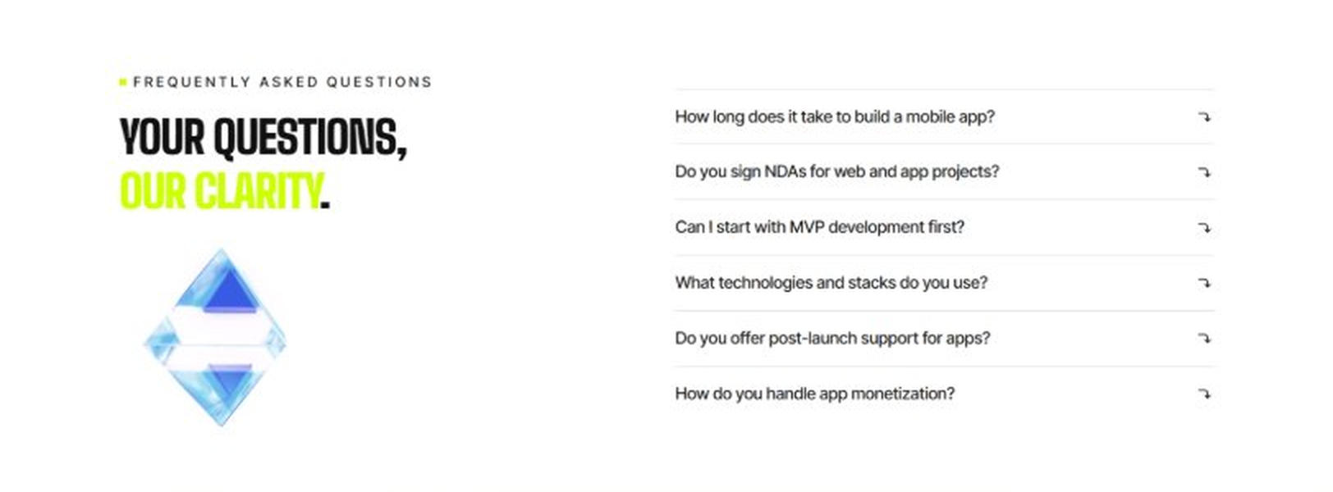
Current live page, www.appsters.io/industry
 | DETAIL
Status | New copy applied
Build Notes | Live block holds 6 accordion rows. New copy holds 6 questions and answers. Clean one to one fit.
Copy For This Fold
PAGE ELEMENT | COPY (WORD FOR WORD)
H2 (Section Heading) | Frequently Asked Questions
FAQ 1 Question | How long does it typically take to build a fully functional logistics app?
FAQ 1 Answer | Timelines depend on fleet size, integration complexity, and routing requirements. Most projects take 12 to 20 weeks for a stable release, including design, engineering, QA, and pilot testing. As a logistics app development company, we provide clear milestones from day one.
FAQ 2 Question | Can Appsters build an AI logistics app with predictive routing?
FAQ 2 Answer | Yes. We build AI logistics apps with predictive routing, demand forecasting, and automated dispatch baked into the core architecture, not added as an afterthought.
FAQ 3 Question | Do you support in-app commerce features as a food delivery app development company would?
FAQ 3 Answer | Absolutely. Many of our Logistics app developers have direct experience building ordering and delivery flows, so we can embed commerce features directly into your logistics platform where it makes sense.
FAQ 4 Question | What makes Appsters different from other Logistics mobile app development company options?
FAQ 4 Answer | We treat routing accuracy, compliance, and uptime as core product decisions, not add-ons. Most Logistics app development companies focus on UI first and scale later. We do both from the start.
FAQ 5 Question | Can you handle sudden volume spikes during peak shipping season?
FAQ 5 Answer | Yes. Our architecture is stress-tested for exactly this kind of load, so a seasonal surge becomes a manageable event instead of an operational crisis.
FAQ 6 Question | What ongoing support do you provide after launch?
FAQ 6 Answer | Our Logistics app development services include post-launch monitoring, feature updates, compliance checks, and infrastructure scaling, so your platform keeps improving long after release.
FOLD 21: Locations
Locations: Our Global Presence
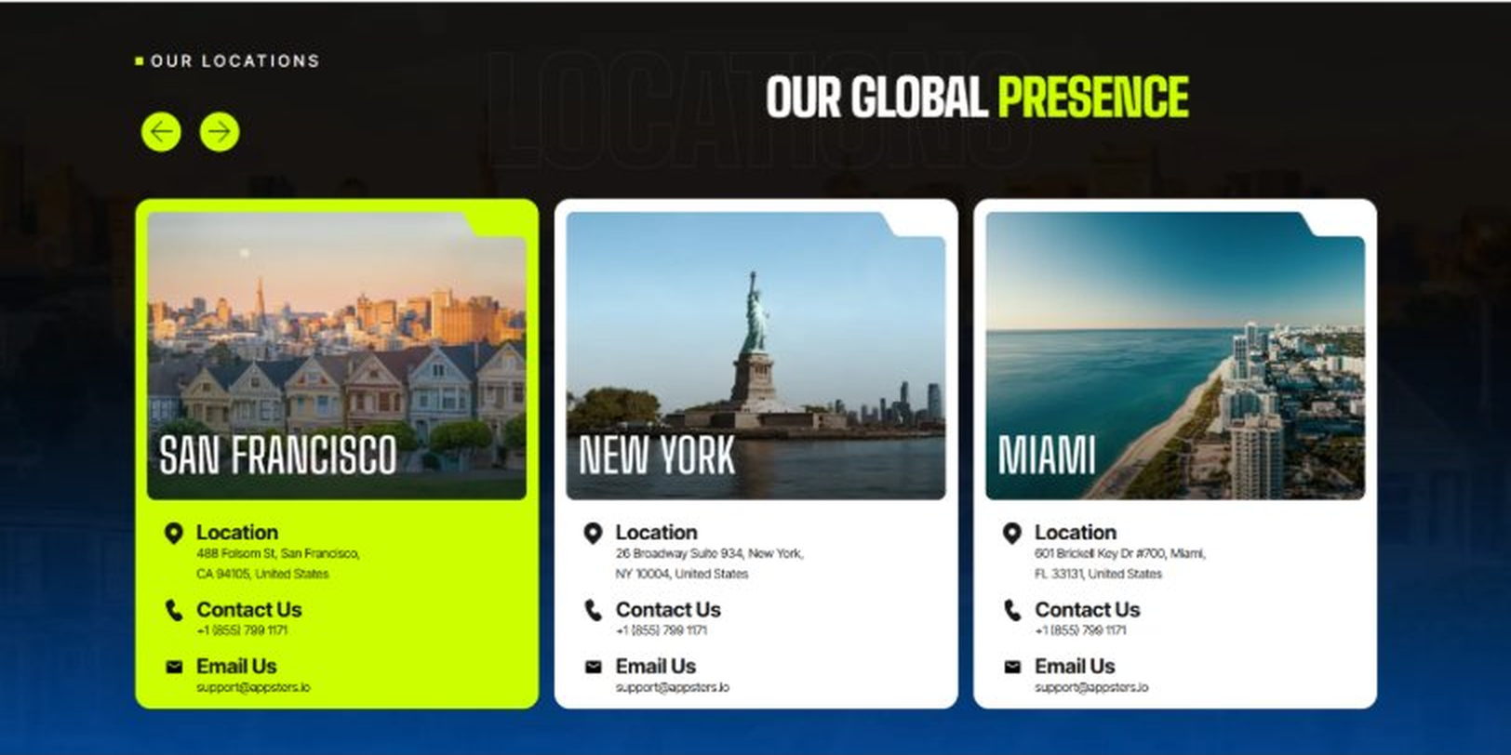
Current live page, www.appsters.io/industry
 | DETAIL
Status | No copy change
Build Notes | No new copy in the source document for this fold. Keep the live block exactly as it is.
FOLD 22: Contact Form
Contact Form: Connect With Us
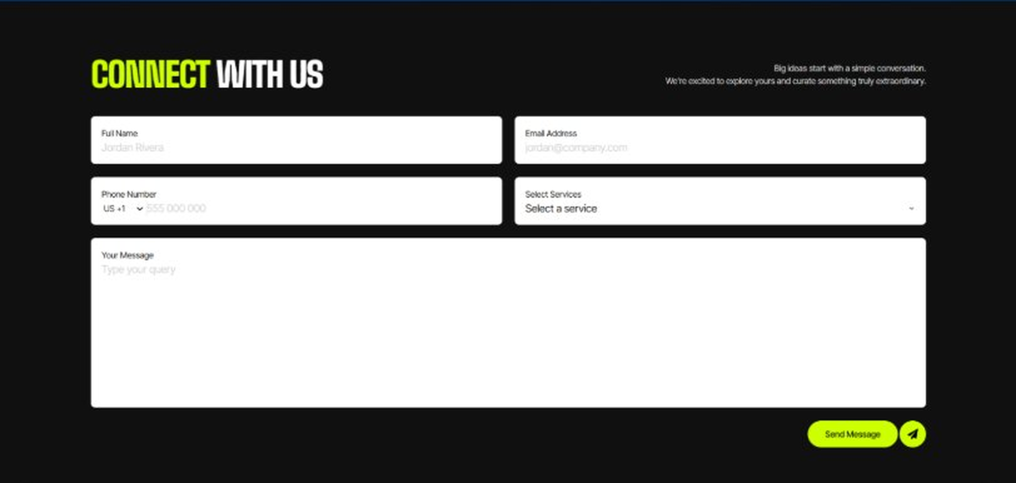
Current live page, www.appsters.io/industry
 | DETAIL
Status | No copy change
Build Notes | No new copy in the source document for this fold. Keep the live block exactly as it is.
FOLD 23: Footer
Footer
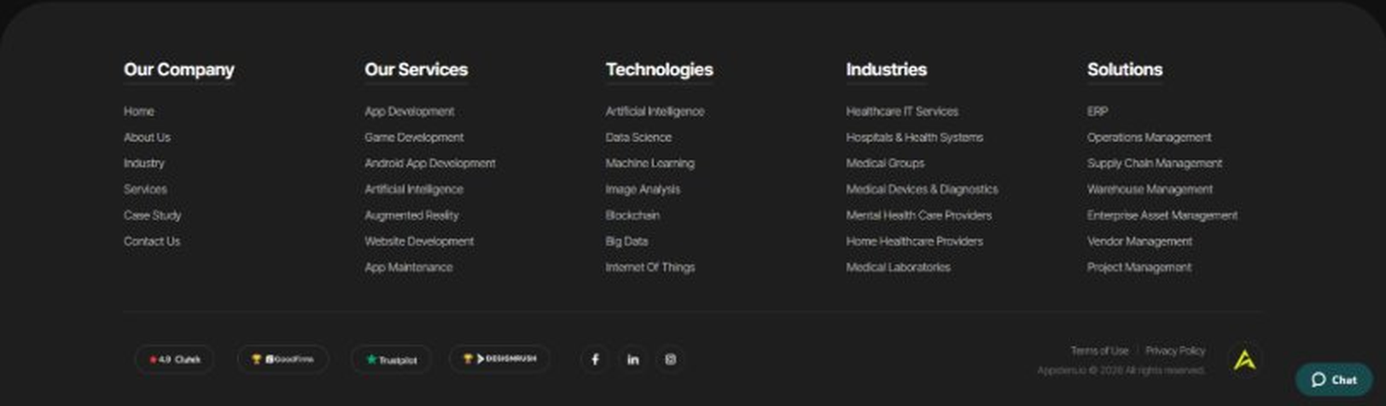
Current live page, www.appsters.io/industry
 | DETAIL
Status | No copy change
Build Notes | No new copy in the source document for this fold. Keep the live block exactly as it is.
NEW BLOCKS REQUIRED
The three blocks below are in the source content but have no matching section anywhere on the current /industry page. Each one needs a new block built.
NEW BLOCK: Distinct Features That Set Our Logistics Apps Apart
 | DETAIL
Status | No equivalent block on the live page
Placement | Suggested placement: directly after Fold 5, reusing the services card grid styling.
Copy For This Block
PAGE ELEMENT | COPY (WORD FOR WORD)
H2 (Section Heading) | Distinct Features That Set Our Logistics Apps Apart
Feature 1 Heading | Dashboard & Admin Panel
Feature 1 Copy | A centralized control center gives your team visibility into fleet status, delivery performance, and driver activity without digging through raw data.
Feature 2 Heading | Push Notifications
Feature 2 Copy | Smart, event-based notifications alert dispatchers and drivers to delays or route changes the moment they happen instead of after the fact.
Feature 3 Heading | Digital Menu
Feature 3 Copy | A structured digital catalog lets shippers browse service tiers, pricing options, and available capacity without a phone call to dispatch.
Feature 4 Heading | Order Tracking
Feature 4 Copy | Real-time order tracking keeps shippers and end customers informed from pickup to final delivery, with accurate ETAs that actually hold up.
Feature 5 Heading | Social Media Integration
Feature 5 Copy | Direct sharing and status updates let logistics brands keep customers informed and build trust through visible, verifiable delivery performance.
NEW BLOCK: Industries We Serve
 | DETAIL
Status | No equivalent block on the live page
Placement | Suggested placement: directly after Fold 10, as a card grid rather than tabs.
Copy For This Block
PAGE ELEMENT | COPY (WORD FOR WORD)
H2 (Section Heading) | Industries We Serve
Body Copy | One Codebase. Infinite Industries. Our web, app, and AI solutions are built to perform, scale, and adapt while setting industry standards and redefining what's possible for businesses everywhere.
Industry 1 Heading | Fintech
Industry 1 Copy | We co-create secure, compliant fintech apps that simplify payments, investments, and trading, using the same transaction infrastructure we build for freight billing and driver payouts.
Industry 2 Heading | Healthcare
Industry 2 Copy | We develop HIPAA-compliant healthcare apps that bridge doctors, patients, and data, applying the same real-time tracking systems we use for cold-chain and medical supply logistics.
Industry 3 Heading | Education
Industry 3 Copy | Our education apps gamify learning and power virtual classrooms, borrowing the same real-time notification systems we use to keep dispatchers and drivers in sync.
Industry 4 Heading | Real Estate
Industry 4 Copy | We design real estate apps that help buyers, sellers, and agents close deals faster, using the same geolocation infrastructure we build for fleet tracking.
Industry 5 Heading | Automotive
Industry 5 Copy | From fleet dashboards to predictive maintenance, we digitize automotive operations using the same telematics expertise behind our logistics platforms.
Industry 6 Heading | Music
Industry 6 Copy | We create streaming apps and artist marketplaces, applying the same real-time notification infrastructure we use to alert dispatchers to route changes.
Industry 7 Heading | Social Media
Industry 7 Copy | We build social platforms that are scalable and sticky, drawing on the same high-availability infrastructure that keeps our logistics apps running during peak load.
Industry 8 Heading | Ecommerce
Industry 8 Copy | We build ecommerce apps with frictionless checkouts and AI product recommendations, backed by the same fulfillment and delivery logic we use across our logistics platforms.
NEW BLOCK: Advanced Technologies That Power Our Logistics Apps
 | DETAIL
Status | No equivalent block on the live page
Placement | Suggested placement: directly after Fold 17, reusing the services card grid styling.
Copy For This Block
PAGE ELEMENT | COPY (WORD FOR WORD)
H2 (Section Heading) | Advanced Technologies That Power Our Logistics Apps
Body Copy | As a logistics app development company built around what's next, we don't stop at maps and tracking pins. Every logistics app developer on our team stays current with tools that keep platforms competitive, from AI route prediction to live commerce. Unlike most logistics app development companies still catching up on food ordering app development trends inside delivery platforms, we're already building AI-based logistics apps with these capabilities baked in.
Technology 1 Heading | AI Integrated Logistics Apps
Technology 1 Copy | We build AI Integrated Logistics Apps with predictive routing, demand forecasting, and automated dispatch, giving operations teams a system that plans ahead instead of just reacting.
Technology 2 Heading | Payment Gateway Integration
Technology 2 Copy | Secure, PCI-compliant payment gateway integration lets your platform handle freight billing, driver payouts, and shipper invoicing without third-party friction.
Technology 3 Heading | Cloud Solutions
Technology 3 Copy | Our cloud solutions keep data-heavy platforms fast and reliable, with autoscaling infrastructure built to absorb peak shipping season traffic.
Technology 4 Heading | MVP For Logistics Apps
Technology 4 Copy | When you need to validate an idea fast, our MVP for Logistics Apps approach gets a functional, testable product into dispatchers' hands without a twelve-month build cycle.
Technology 5 Heading | API Integration
Technology 5 Copy | We connect your platform to carrier networks, warehouse systems, and other logistics ecosystems through clean, well-documented API integration.

